My Log Book  Name:  Age:  School: |  |  |  |  | 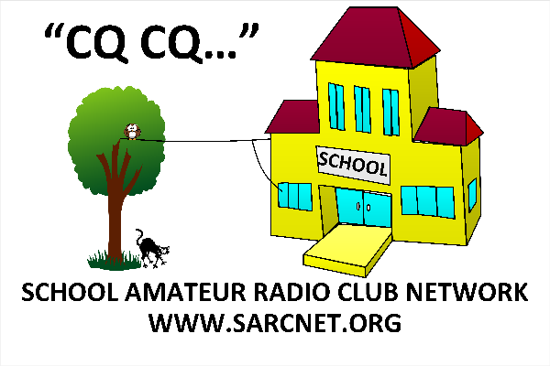
DATE | TIME | BAND | FREQ | MODE | CALL | NAME | RCVD | NOTES
DATE | TIME | BAND | FREQ | MODE | CALL | NAME | RCVD | NOTES

